**EXPERIMENT 5**

**AIM: *Working with Dockerfile to Build and Push Docker Image***

**Steps to Complete:**

1. Create following Dockerfile

* **FROM alpine**
* **MAINTAINER SUDIPT**
* **RUN apk update**
* **RUN apk add nodejs**
* **RUN mkdir /app**
* **WORKDIR /app**

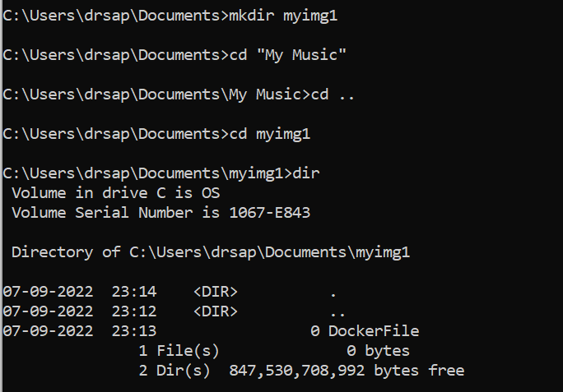

1. Now we have dockerized the app, we will Build image from Dockerfile.

Command: **docker build –t myimage:1.0 .**

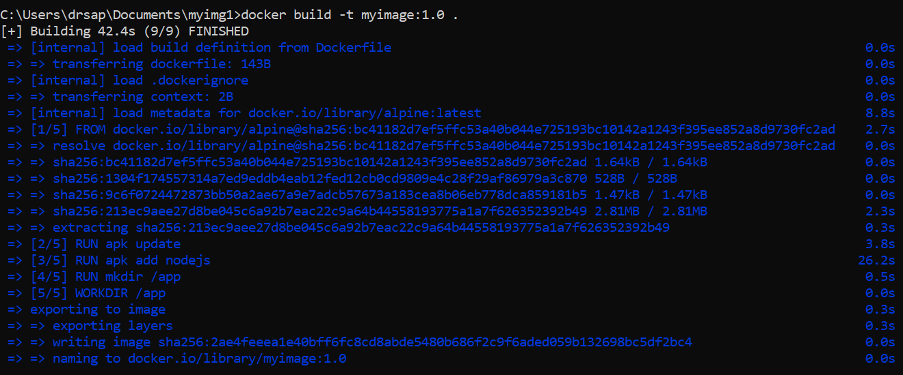

1. Create account on Dockerhub and create a repository in it.

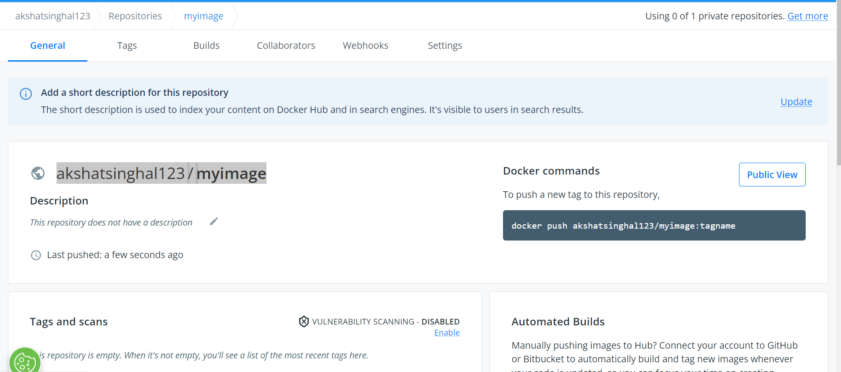

1. Tag the recently created image using following command.

Command: **docker tag 2ae4feeea1e4 akshatsinghal123/myimage:1.0**



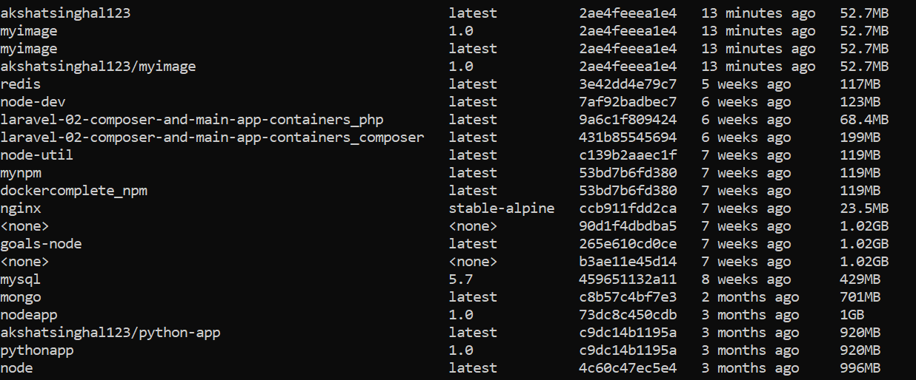

1. Login to Dockerhub from console using following command.

Command: **docker login**

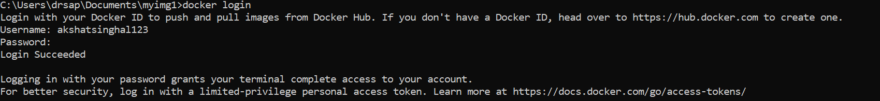

1. Now push the image on Dockerhub using following command.

Command: **docker push akshatsinghal123/myimage:1.0**

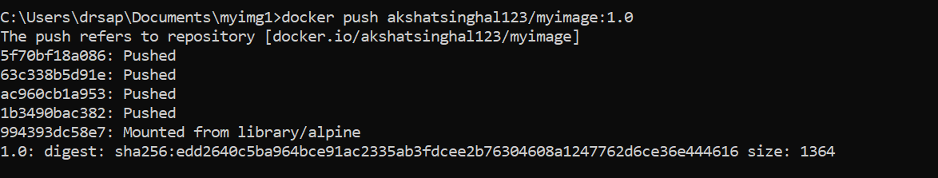

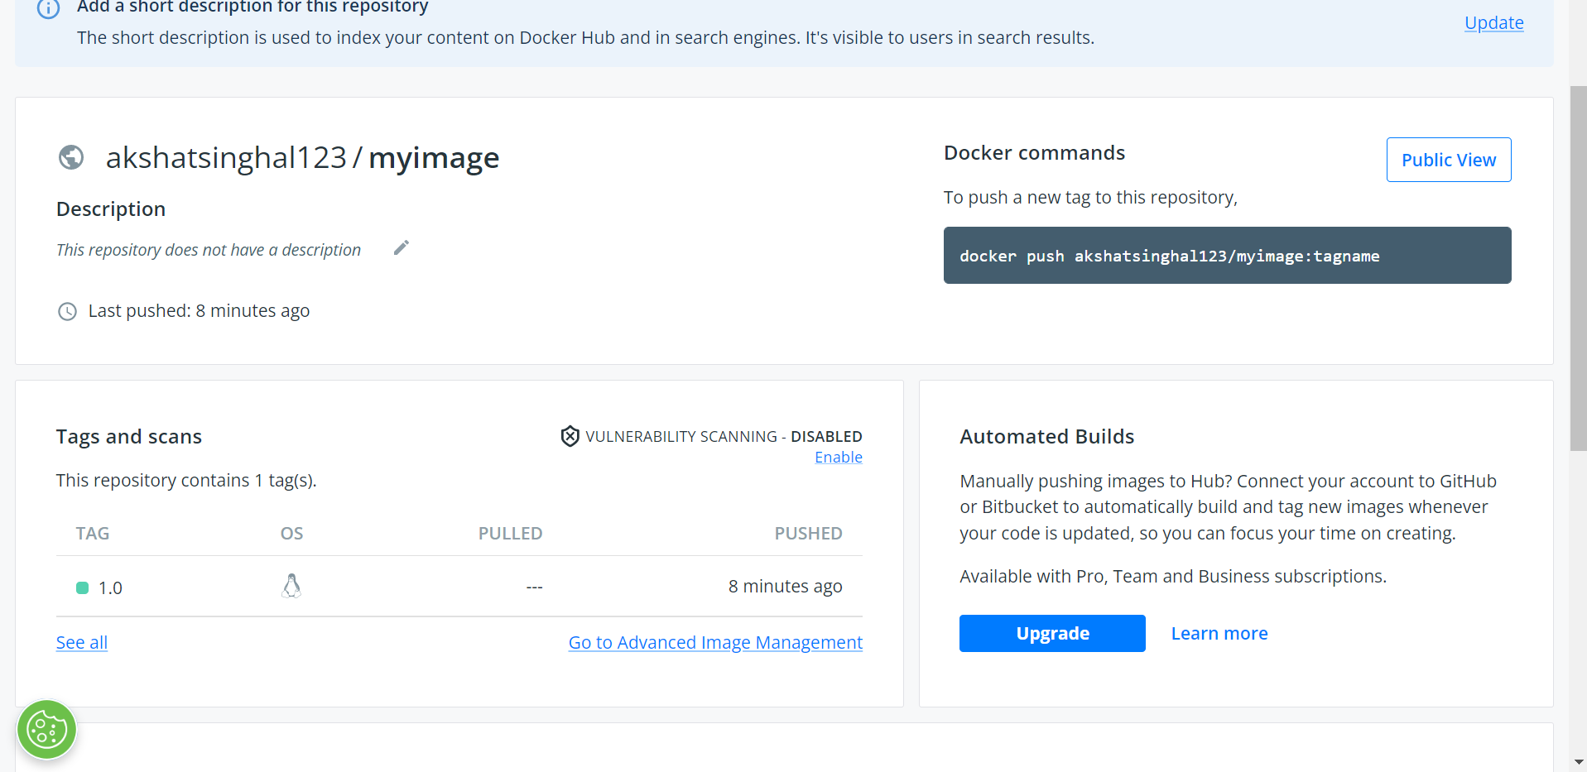

1. Pull and Run the container of your deployed image on docker hub.

Command:

**docker pull akshatsinghal123/myimage:1.0**

**docker run -d akshatsinghal123/myimage:1.0**

